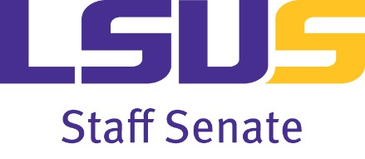 | Staff Senate Support Fund  Payroll Deduction Registration Form
The LSUS Staff Senate was organized for staff employees in January 1994 to serve in an advisory and consultative role with the University Administration to promote understanding, cooperation, and communication within the LSUS campus community.
The Staff Senate is made up of classified and unclassified employees. Those who serve on the Staff Senate are elected by their peers or by submitting their name to serve on the Staff Senate for a three-year term.
Senate meetings are held every month during the regular academic year and are open to the public. We encourage attendance and involvement on committees for all staff members.
Employees can also get involved by enrolling in the Staff Senate Support Fund Payroll Deduction program. The payroll deductions are as follows:
$1.00 per paycheck for hourly (classified and non-exempt unclassified) employees,
$2.00 per paycheck for salaried (exempt unclassified and 12-month faculty) employees,
$2.66 per paycheck for 9-month faculty
The payroll deductions will help support Staff Senate sponsored programs such as:
- The annual Faculty-Staff Holiday Luncheon*
- The annual Faculty-Staff Spring Luncheon*
- Tailgate parties for LSUS sporting events
- Lunch and Learn programs that promote faculty/staff personal and professional development
Become a Staff Senate supporter!
  - Yes, I want to sign up for the Staff Senate Support Fund payroll deduction.
I authorize LSUS to deduct $ ________ per paycheck as my contribution to the LSUS Staff Senate Support Fund. My payroll deduction will continue until I cancel my membership in writing or my employment with LSUS terminates. I understand that I may cancel my membership at any time and that all donations are non-refundable.
Employee Name | Workday ID
Department | Phone
Employee Signature | Date
*Current members are guaranteed FREE admission to these events.
Please complete and return this form to the Human Resources department
in room 108 of the Administration Building.
Thank you for supporting your Staff Senate!

