MEMORANDUM:

To: University Community
From: Dr. Robert T. Smith, Chancellor
Date: January 21, 2026

Re: Agenda – January 22, 2026 LPC Meeting

The LSUS Planning Council will meet on Thursday, January 22, 2026, at 2:00 p.m. on the third floor of the Noel Memorial Library. The meeting is open to all members of the university community.

- Chancellor, Chair: Robert T. Smith
- Provost and Vice Chancellor for Academic Affairs: Helen Taylor
- Vice Chancellor for Finance & Administration: Shelby Keith
- Vice Chancellor for Student Affairs: Demitrius Brown
- Associate Provost: Helen Wise
- Chief of Staff: Kim Ramsey
- Associate Vice Chancellor for Community Engagement: Kenna Franklin (absent)
- Faculty Senate President (or Assign): College of Education & Human Development: Cassandra Williams (absent)
- Faculty Representative: College of Business: David Fowler
- Faculty Representative: College of Arts & Sciences: Jorji Jarzabek
- Dean of Graduate Studies: Sanjay Menon
- Dean, College of Business: Mary Lois White
- Dean, College of Arts & Sciences: Tibor Szarvas
- Dean, College of Education & Human Development: Allen Grant (absent)
- Dean, Noel Memorial Library: Brian Sherman
- Senior Associate Vice Chancellor/Dean of Students: Paula Atkins
- SGA President (or Assign): Devesh Sarda
- Staff Senate Representative (or Assign): Business or Student Affairs: Angela Burton
- Chief Information Officer: Scott Hardwick
- Director, Human Resources: Robert Lindsey
- Director of Alumni Development: Jazmin Jernigan (absent)
- Director, University Athletics: Lucas Morgan
Ex-Officio (Non-Voting)
  - Executive Director, LSUS Foundation: Laura Perdue
  - Director, Media and Public Relations: Erin Smith
  - Executive Assistant to the Chancellor: Brandy Hayse

- Welcome and remarks (Smith)

Chancellor Smith welcomed everyone to the meeting and stated that spring enrollment looks like it’s going to be up by about 2%, which is great after having a record number of graduates for the fall. He mentioned LSU President Rousse visited campus this morning for the Kemp Forum and asked everyone to please watch their phones and emails for RAVE alerts regarding the weather. Chancellor Smith asked everyone to go watch the Pilots baseball opening game. He stated that we have officially launched the Center for Northwest Louisiana Regional Impact and introduced the new Director for the Center, Jessica Hemingway.

- Approval of minutes from November 24, 2025 LPC meeting

The minutes from the LPC meeting on November 24, 2025 were approved as distributed.

- Request for new positions (Keith)

Shelby Keith stated that Academic Affairs positions will be funded through tuition, and the Student Affairs positions will be funded by the Student Success Center Fee.

Provost Helen Taylor reported on the hiring request for an Instructor of Finance and stated that this position will support the growth in enrollment for the College of Business and allow for more in-person finance classes.

Vice Chancellor Demi Brown reported on hiring requests for Student Affairs. Stating that 4 new positions for Centralized Advising will support student advising ratios. Adding, these hires will allow 250 students to be supported per advisor. Noting that the national recommendation is about 200 per advisor, so we are getting there.

Devesh Sarda asked if the current advisors located in the colleges will be pulled into the Centralized Advising space. Michael Anderson stated yes, we will eventually transition all to one place. Demi Brown added that we are working on a space plan for this transition.

Brian Sherman asked if advisors would have teaching duties. Angie Pellerin stated yes, if advisors are qualified, they will be required to teach one section of first-year experience.

- Additional projects for fiscal ’26 (Keith)

Chancellor Smith asked Shelby Keith to report on projects and stated that many of these projects are funded by self-generated funds from additional revenue from increased enrollment and tuition. Adding, we have been investing these funds into various small and medium-sized campus projects.

Shelby Keith reported on projects that have been completed and those in progress.

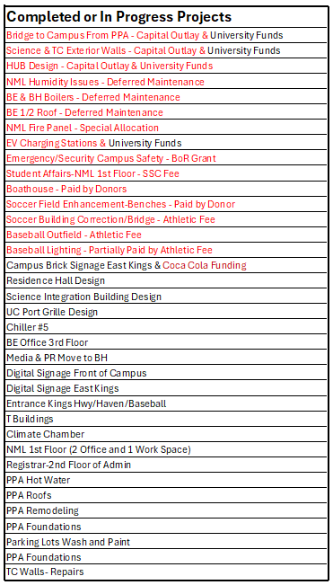

Mary Lois White asked about the status of the Business Education building 3rd floor office spaces. Shelby Keith stated that the design is with the architect, which is what we need for procurement to move forward.

Shelby Keith reported on new projects.

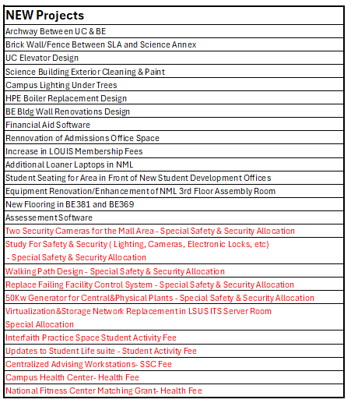

Mary Lois White asked if the archway between the University Center and Business Education would include all the columns. Shelby Keith stated yes, all columns will be part of this project.

Shelby Keith discussed the location of the walking path project and asked for input regarding the material of the path being concrete or asphalt. Feedback was given for asphalt.

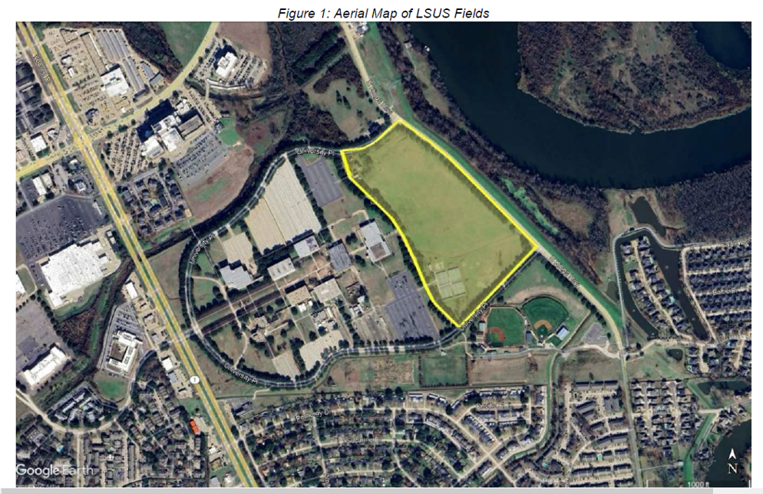

Chancellor Smith stated that we are reinvesting in our campus to attract students.

- Review of new/revised policies (Ramsey)

Shelby Keith report on Policy 1.02.01 Use of University Funds for Entertainment/Special Meals,
Policy 1.20.01 Return to Work Policy for Workers, and Policy 3.28.00 Guidelines for Reimbursement of Expenses for Prospective Students with Special Talents.

Shelby Keith added that there will be 14 new IT policies coming to LPC soon.

- Updates from Cabinet and other Administrative Officers

Provost Helen Taylor reported that we will be sending a proposal for an MS in Biotechnology and a BS in Nursing to the Board of Supervisors. Also reported that we are having lots of faculty candidates to campus and that Academic Affairs has moved to centralized scheduling. Provost Taylor will be asking deans to submit their draft schedules by March 1st.

Helen Wise reported that we will be taking a group of about 25 faculty and staff to the Meauxmentum Summit, February 3-4. CELT is leading a faculty reading on Becoming a Mentor. Academic Affairs has 2 jobs opening going out next week. Coordinator of Institutional Effectiveness and Chief Online Learning Officer.

Demi Brown asked Trish Farnsworth-Smith to report on Pilots Pointe Apartments' readiness for the incoming weather. Demi also thanked Shelley Moore for her active participation with the UNO transition.

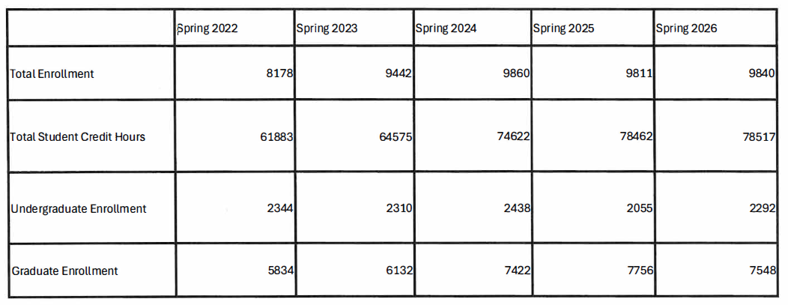
Shelley Moore reported on current enrollment. Stating we are steady, moving forward, and excited about campus updates and new programs, this is essential with recruitment. Shelley shared the pre-census enrollment numbers below, noting that these numbers are not final and do not include Dual Enrollment.

Chancellor Smith asked if we have seen any traction from the new Allied Health programs? Jennie Bynog stated that we are starting to see interest.

Angie Pellerin introduced her new team members. Kirsten Nolen, Transfer Success Specialist, Jacob Slaughter, Student Success Operations Manager, and Tiffany Robinson, Academic Advisor, College of Arts and Sciences Lead.

Demi Brown reported on the search for the Director of Student Life. Adding, despite weather delays, we are hoping to fill the position soon.

Shelby Keith noted that enrollment numbers will be increasing and gave kudos to Dual Enrollment, headed by Elisabeth Liebert

Erin Smith report on Media and Public Relations moving to Bronson Hall. Erin stated the LSUS Brand Guide was pushed out last week and thanked everyone for their engagement. Noting more ADA guidelines will follow.

Rob Lindsey reported on annual evaluations and planning sessions. Stating that all are due by February 20th. Rob also noted that HR will be sending out a notice tomorrow to submit hourly employee time and approvals.

Scott Hardwick asked everyone to check their Workday numbers and email for Rave alerts.

Kim Ramsey updated on the upcoming DC Mardi Gras Washington trip next week.

- Off-agenda items

- Comments from the audience

- Next scheduled LPC meeting: February 23, 2026

- Adjournment

