Student Tax Filing Status – Independent
2026-2027

First Name | }firstname{ | Last Name | }lastname{
Student ID # | }studentid{ | Cell Phone | }cellphone{
Email Address | }email{

Select one of the options below and provide the associated documentation:
I did file a 2024 federal tax return with the IRS, either an individual/separate return or a joint return with spouse. I will submit a copy of my 2024 federal tax return.
I did NOT file a 2024 federal tax return, did not work in 2024 and had no wages. I will also request a “Verification of Non-filing Letter” from the IRS as detailed below.
I did NOT file a 2024 federal tax return, but did work in 2024. My wage information is reported below and I will attach all 2024 W-2 forms below. I will also request a “Verification of Non-filing Letter” from the IRS as detailed below.

Employer’s Name | Amount Earned in 2024

You MUST sign your tax return before attaching it to this document. Please use the example below to locate the signature portion on your tax return. If the signature block is blank or you signed electronically, please sign before submitting. Unsigned taxes will not be used and will slow down the financial aid awarding process.

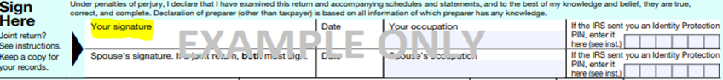
I have signed my 2024 tax return. (Only required if you chose the first item above.)

If you did not file a 2024 tax return, you MUST request a ‘Verification of Non-filing Letter’ from the IRS. Request the ‘Verification of Non-filing Letter’ at https://www.irs.gov/individuals/get-transcript or by completing IRS Form 4506-T, https://www.irs.gov/pub/irs-pdf/f4506t.pdf . If you complete Form 4506-T, make sure you check box 7 and mail/fax the form to the appropriate address/number. Do not attach Form 4506-T to this document.

By signing below, I (we) certify that all information provided on this form and any supporting documentation I have submitted is complete and correct to the best of my knowledge. I understand if I purposely give false or misleading information, I may be fined, sentenced to prison, and/or removed from school. Applications suspected to contain fraudulent information will not be awarded federal financial aid.

Signature |  | Date
 | }studentsignature{ | }studentsignaturedate{

